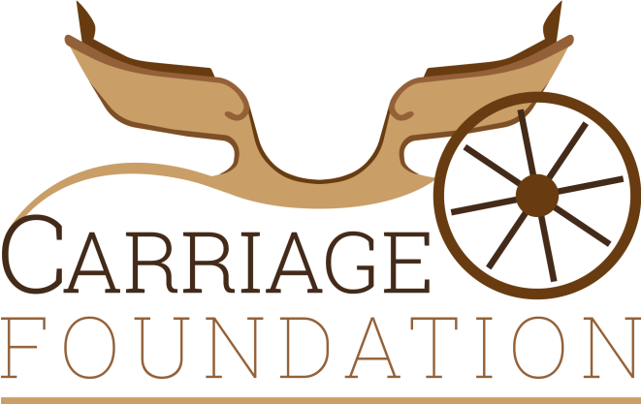
Patron: HRH Prince Michael of Kent

Study Day Booking Form
Museum of the Horse, Tuxford
22nd and 23rd October 2016

Name:

Address:

 | Saturday 22nd October fee: £35.00 adults £25.00 child | Sunday 23rd October fee: £35.00 adults £25.00 child | Both days  fee: £60.00 adult £40.00 child
ADULT
CHILD

Please or send payment via the following methods:
Cheque payable to The Carriage Foundation
Paypal to: thecarriagefoundation@yahoo.co.uk
Bank Transfer to: Account number 53562534, Sort Code 60-14-15

